Trichuris trichiura (Whip worm)
Name of Disease : Trichuriasis
Intermediate and final host: human ,Equine, Ruminants and dogs
Sit of infection: large intestine.
Transmission.
Infection occurs when humans ingest infective eggs through contaminated hands, food, or soil , Contaminated vegetables are a common source of outbreaks and Rare cases of transmission through sexual contact have also been reported.
Diagnostic Features and Morphology.
Female:
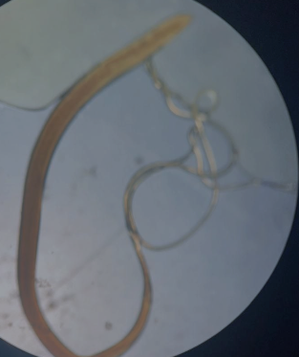
The female measures 35–50 mm in length and exhibits a distinctive whip-like appearance, with the anterior three-fifths being thin and the posterior two-fifths thick. The cellular esophagus occupies the entire slender anterior region, while the intestine and reproductive organs are confined to the thicker posterior part. The vulva is located at the junction between the thin and thick portions of the body.

Male:
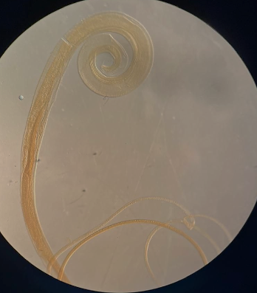
The male measures 30–45 mm in length and is similarly composed of a narrow anterior part and a thicker posterior part. It possesses a single spicule enclosed within a retractile spine covered by a protective sheath.
Spicules

Eggs
The eggs are barrel- or lemon-shaped, measuring approximately 50–55 µm in length and 25 µm in width. They contain a one-cell stage embryo at the time of oviposition. Each egg has a thin, transparent inner membrane and a golden-brown outer shell, with two prominent polar plugs, which are characteristic of the species.
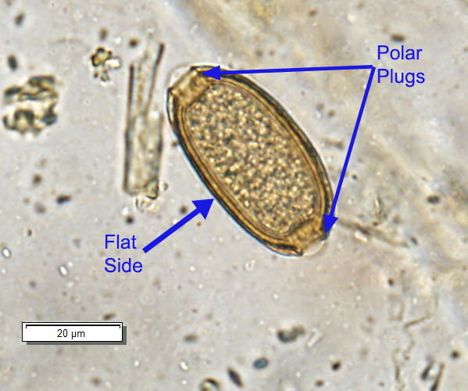
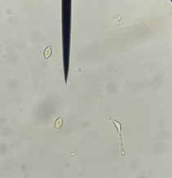

Trichinella spiralis

Name of Disease: causes a disease called Trichinosis ( Pork Tap worm).
Definitive host: Dog, cats, pigs, rodents, rabbits, birds.
Site of infection: mucosa of small intestine
Intermediate host: Dog, cats, pigs, rodents, rabbits, birds.
Site of infection: Larva in Striated skeletal muscles.
Transmission:
Humans typically become infected by consuming raw or undercooked meat containing encapsulated larvae. Common sources include pork, wild game, and other carnivorous animals
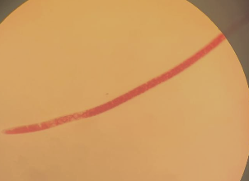
Female:
The female measures 3-4 mm in length.
Cellular esophagus. One set of genitalia
only; the ovary Situated at the posterior
end, uterus proceeds to open in vulva
at junction of anterior 5th with the rest of the body.
At the posterior end, the uterus contains eggs gradually mature and then hatch (viviparous) 1st stage of larvae released into intestine

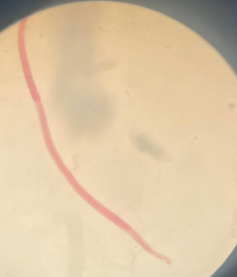
Male:
The male measures 1.5 mm in length
. Cellular oesophagus. The cloacal opening
is terminal and is guarded by
a pair of conical papillae .
Papillae

Encysted larvae: Larvae tend to lie in the longitudinal axis of
the muscle fibers, each larvae is encysted singly or in heavy
infections 2 or 3 larvae may encyst together. Larvae takes a spiral
or figure 8 appearance. Cyst wall of fibrous tissue made up by
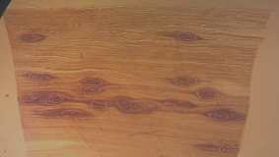
reaction of the host.
Encysted larvae like figure 8

